

*A service may include a selection of poetry, scripture readings or other inspirational passages, music, songs and prayers.*

*At its heart, is an engaging eulogy that remembers, treasures, brings hope*

*and offers* *encouragement.*

*Jimmy O’Donnell (Lancashire Memories) – Funeral Celebrant*

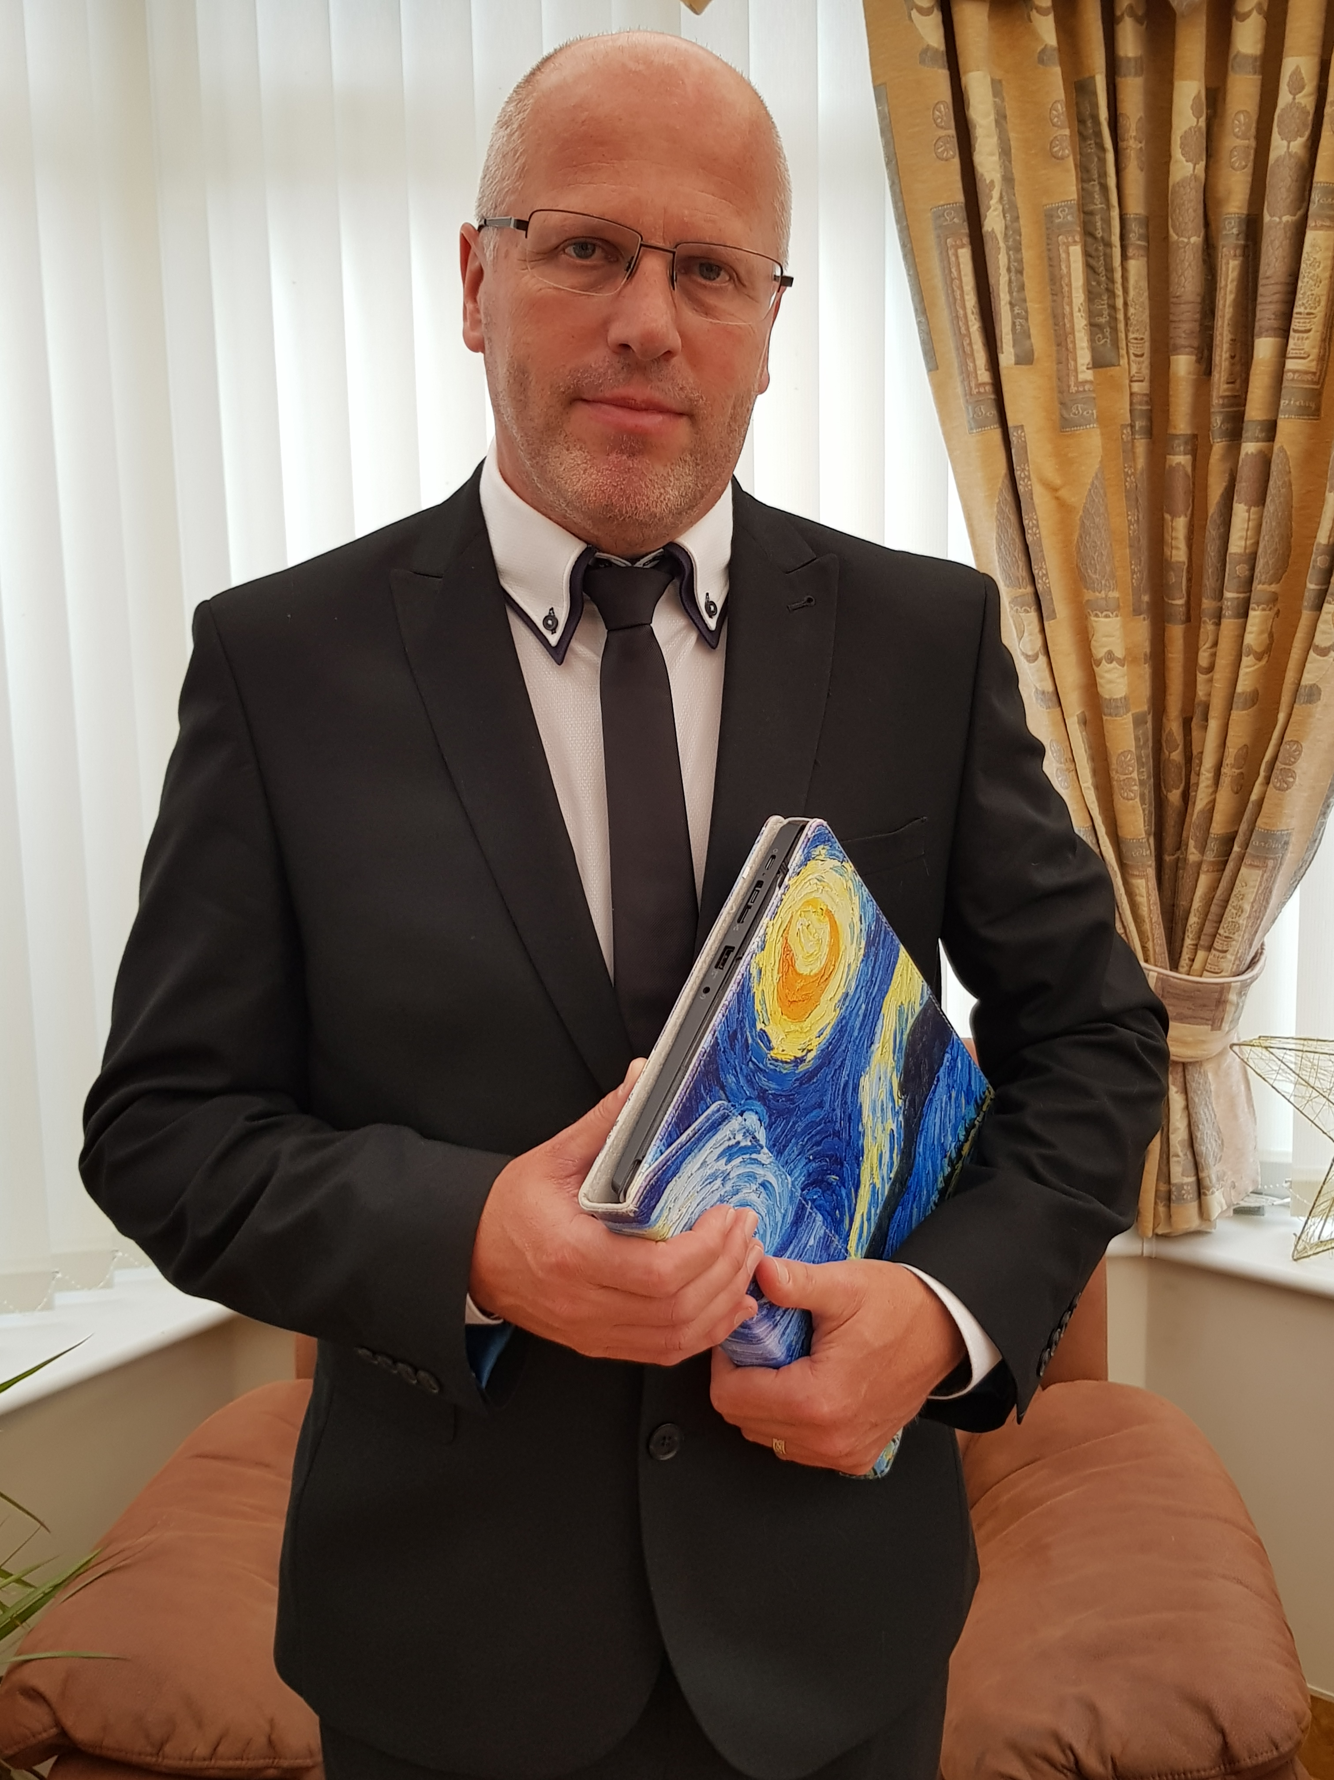

*Jimmy O’Donnell*

*O7761-071696 / 01253-446688*

[*lancashirememories@hotmail.com*](mailto:lancashirememories@hotmail.com)

*@lancsmemories*

[*www.lancashirememories.com*](http://www.lancashirememories.com)

*Jimmy supports families in creating a dignified and meaningful funeral service*

*that helps to meet their needs,*

*with or without a faith element.*

*Planning a funeral service can present a significant challenge for people during a most difficult and emotional time in their lives. Jimmy’s experience, skills and compassion, empowers families to honour the memory of the person, affirm their life story and find some comfort and peace.*